

***C# BASICS***

**Training Assignments**

|  |  |
| --- | --- |
| Document Code | 25e-BM/HR/HDCV/FSOFT |
| Version | 1.1 |
| Effective Date | 20/11/2012 |

**Hanoi, 06/2019**

RECORD OF CHANGES

|  |  |  |  |  |  |
| --- | --- | --- | --- | --- | --- |
| No | Effective Date | Change Description | Reason | Reviewer | Approver |
|  | 01/Oct/2018 | Create new | Draft |  |  |
|  | 01/Jun/2019 | Update template | Fsoft template | DieuNT1 |  |
|  |  |  |  |  |  |
|  |  |  |  |  |  |
|  |  |  |  |  |  |
|  |  |  |  |  |  |
|  |  |  |  |  |  |
|  |  |  |  |  |  |
|  |  |  |  |  |  |
|  |  |  |  |  |  |

Contents

Day 5: Assignment 17: Outlook emulator with IO 4

Objectives: 4

Business needs: 4

Prerequisites: 4

Requirement: 4

Software Requirement: 4

Technical requirements: 5

1. Exercise 1: 6

2. Exercise 2 6

3. Exercise 3 6

4. Exercise 4 6

|  |  |
| --- | --- |
|  | **CODE: Net.M.A017**  **TYPE: MEDIUM**  **LOC: 190**  **DURATION: 180 MINUTES** |

# Day 5: Assignment 17: Outlook emulator with IO

**Objectives:**

* Understand and practice with IO library in C#.
* Practice code in Visual Studio.
* Follow coding convention.

**Business needs:**

* TBD

**Prerequisites:**

* Working environment: Visual Studio 2013 or higher.Practice code in Visual Studio
* Each exercise is one project inside 1 solution.

**Requirement:**

The following program describes the operation of the Outlook application. Allow users to edit email content and send.

Allows users to save email lists to xml files, read content from xml file.

**Software Requirement:**

Students write the console application to make the request as follows:

Input: users in turn enter the information of the email including:

* From: email sender
* To: recipient's email(one or more)
* Cc: email of the same recipient( one or more)
* Subject: email header
* Attachment: name of the attachment file
* Mail body: the content of the email. Can enter multiple lines, may contain special characters
* Is Important: Whether the email markup is important or not
* Password: If Is Important is TRUE, then show more password for user to enter. The saved password needs to be encrypted.
* Sent (Yes / No): If you select Yes, save the entered information, if No is selected, re-enter it from the beginning

Output: shows the email the user entered with additional information

* Sent: is the time to save information

**Technical requirements:**

* Write on console application, comply with Fsoft coding conventions
* Build class corresponding to object <Outlook mail>
* Validate the data entered from From / To must be the email format
* Use one of the encryption algorithms to encrypt passwords

1. Exercise 1:

Build the <Outlook mail> class corresponding to the description above.

1. Exercise 2

Build the console application application that allows users to enter information as described:

* Email body: allow users to enter multiple lines.Pinsh typing when meeting <END>,
* Password encryption.

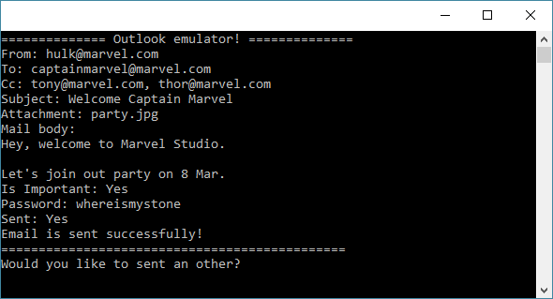

1. Exercise 3

Check the information before initializing the object:

* If you have a password, encrypt the password before saving;
* Check for exception: if To be empty or not email of @ marvel.com, it is not allowed to save, throw out exception "Email format is not our company."

If the condition is met:

* Initialize the <Outlook mail> object, assign the corresponding values;
* Initializing the Sent value is the current time value;
* Add this object to the email list;

1. Exercise 4

Sort email list according to Subject field

Display the imported email list: From, To, Subject